Name =

Abubaker Attique

Class =

5-A

Roll no =

P20-0560

Lab 7

Task 1: WLAN Configuration on Packet Tracer

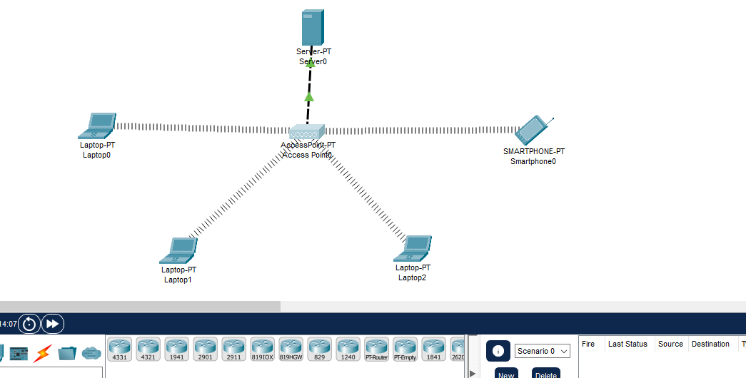

**Place Wireless Interface Card to Laptops**

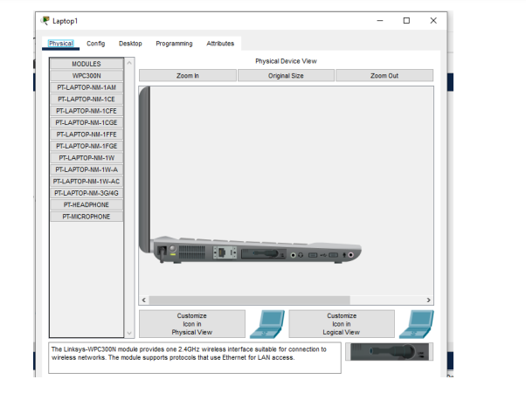

**IP Check on WLAN Devices**

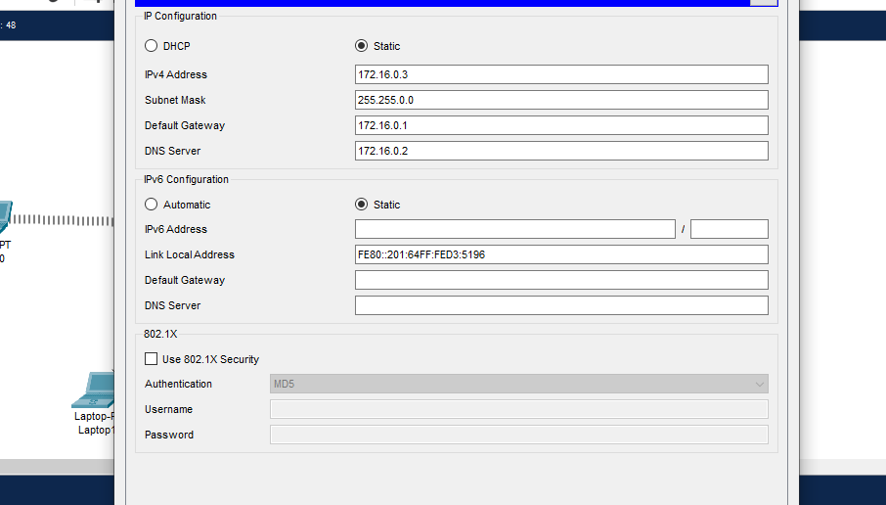

**DHCP Server Configuration**

After the DHCP Services configuration on DHCP Server, we will configure one more thing on this DHCP Server. This is the IP address and subnet mask of the Server.

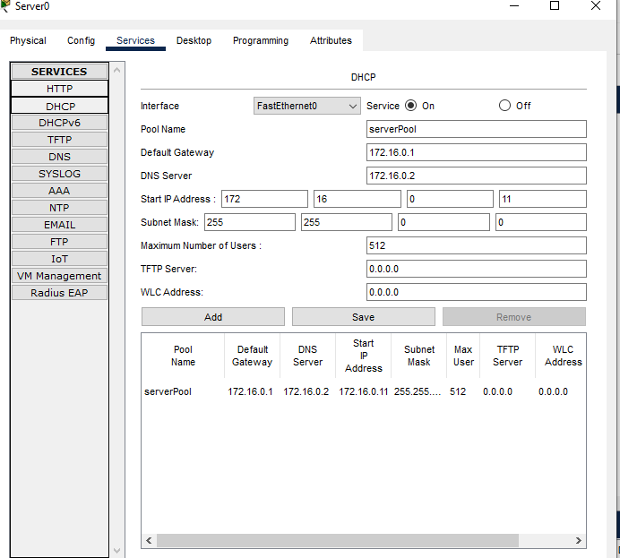

Here, our Server IP address will be 172.16.0.3 and the mask will be 255.255.255.0.

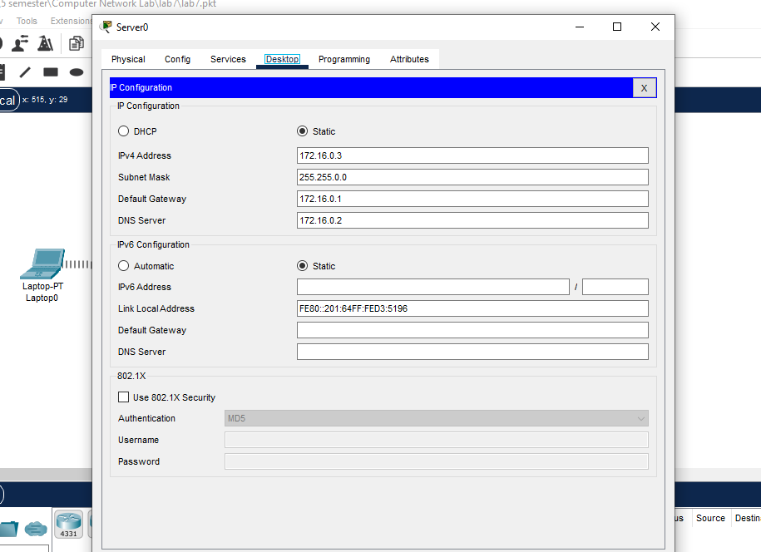

**Task 2: Wireless Router configuration in Cisco Packet Tracer**

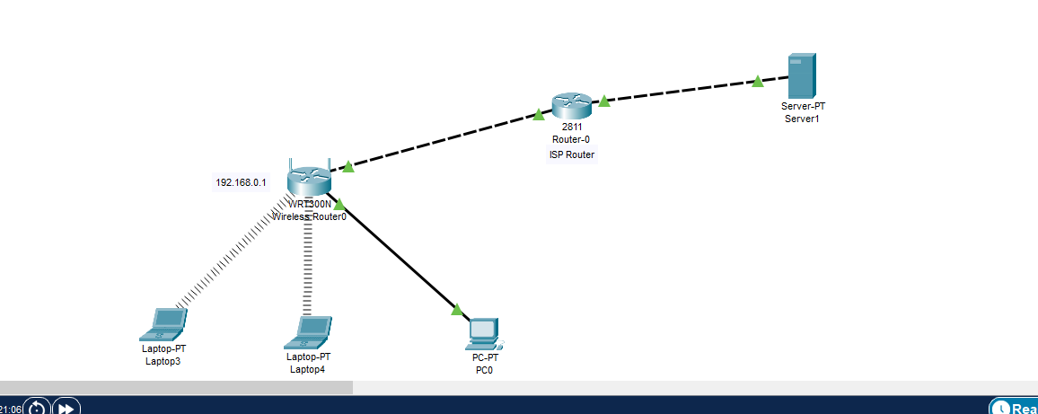

In this setup, we will have two laptops and a PC which should connect to a LAN provided by one wireless router. The PC is used by the network Admin and connects to the LAN via an Ethernet port of the wireless router. The laptops should connect to the same LAN by wireless means, and for this reason, we’ll install wireless adapters on them. Still, we’ll need to connect the LAN to the internet via an ISP router.

**Wireless LAN configuration**

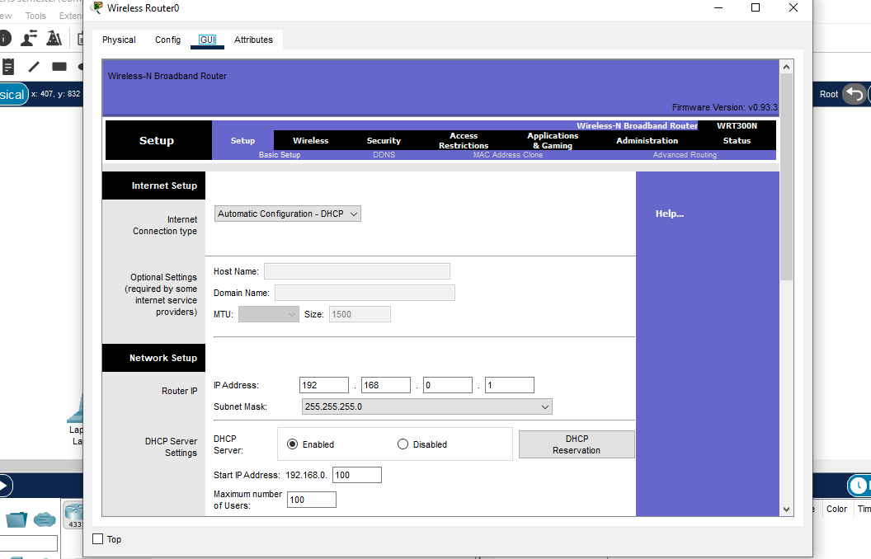

Click on the Administration tab and set a new password for administrative access. Scroll down and Save settings. You will be prompted for a username and the new password you just set.Type them and click OK. Wait a bit. A new screen appears confirming settings are successful. You can click on continue to continue with configurations.

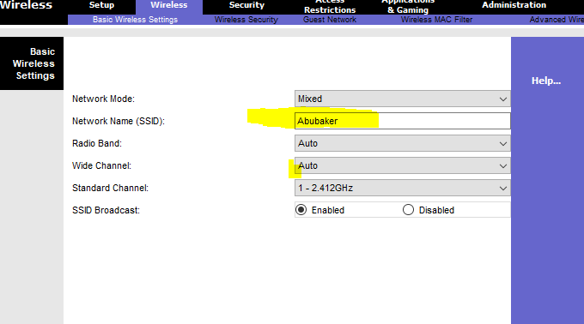

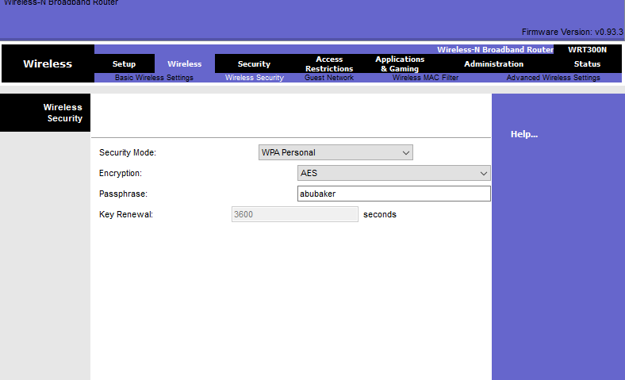

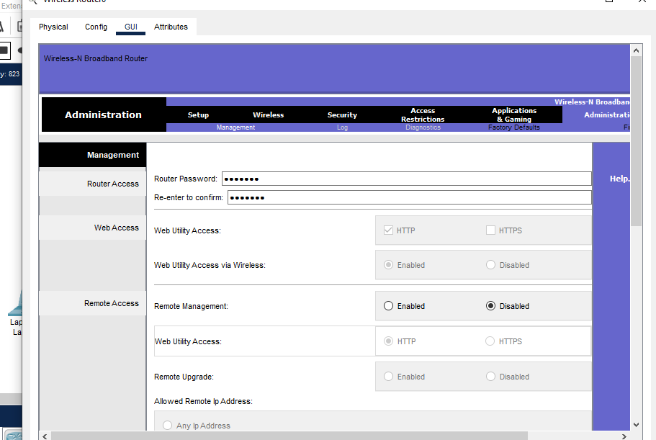

**LAN Setup and Internet Setup**

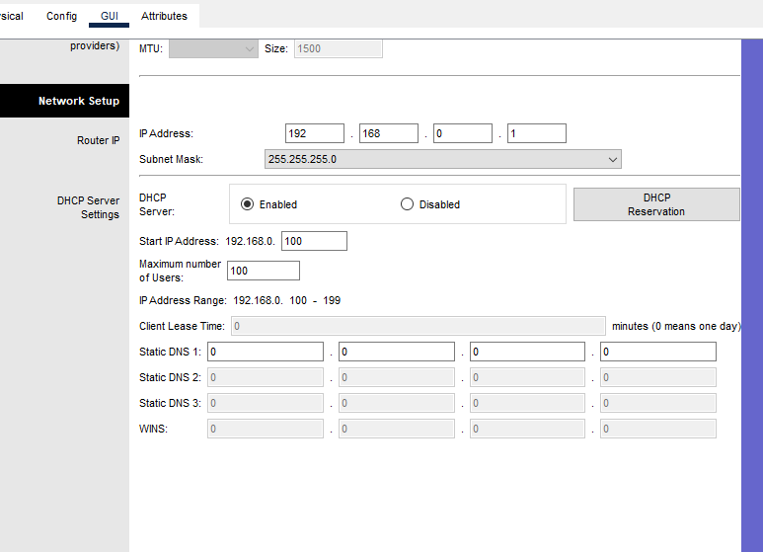

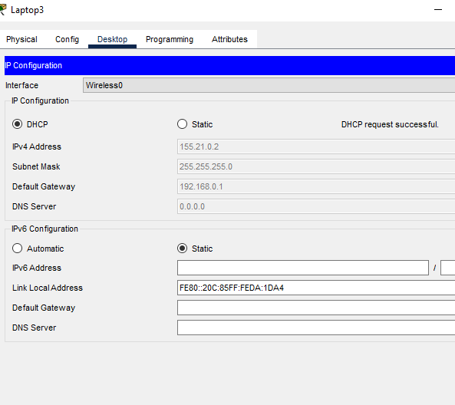

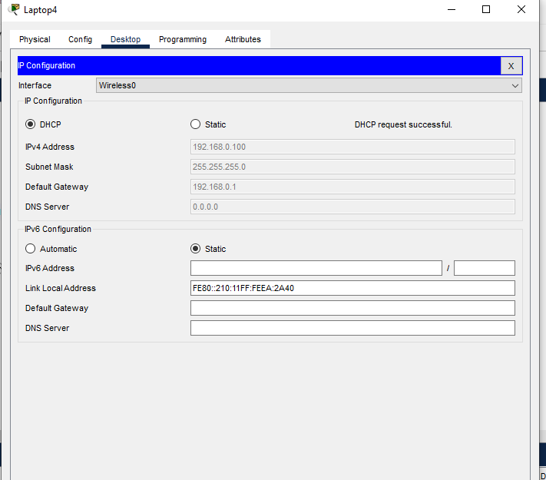

Ping PC2 from PC1. Ping should succeed. Try also to ping the LAN interface of the router from one of the PCs ,say, PC1 . It should be successful.

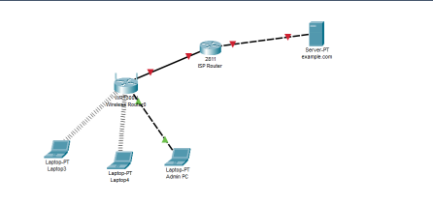

**Adding security for wireless LAN access**

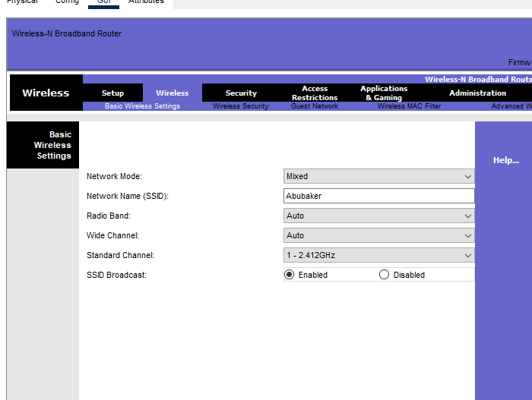

**Disconnect pcs because you are now secure**

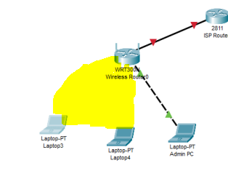

**These yellow is now disconnected because the router have now secured having password.**

**For Connection :**

Again, click connect, then provide the security pre-shared key for the WiFi that you set, then connect. Laptop 1 is now connected to the WiFi network. You can see at the bottom right of the screen that the wireless network adapter on the laptop is active. Repeat this process for the Laptop2.

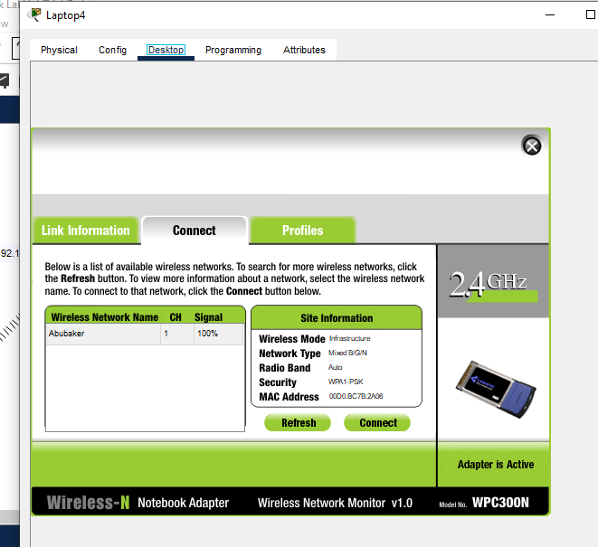

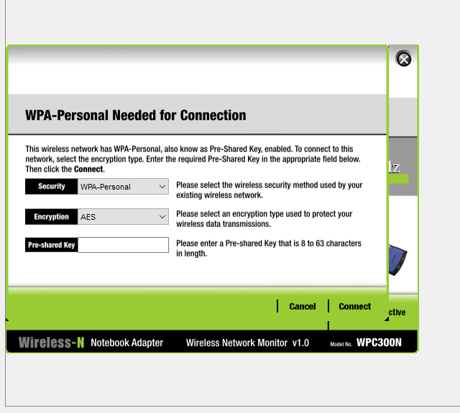

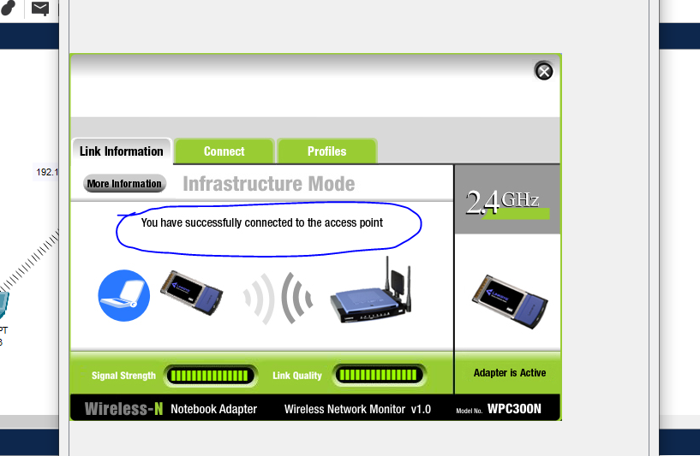

**Now the pc is connected.**

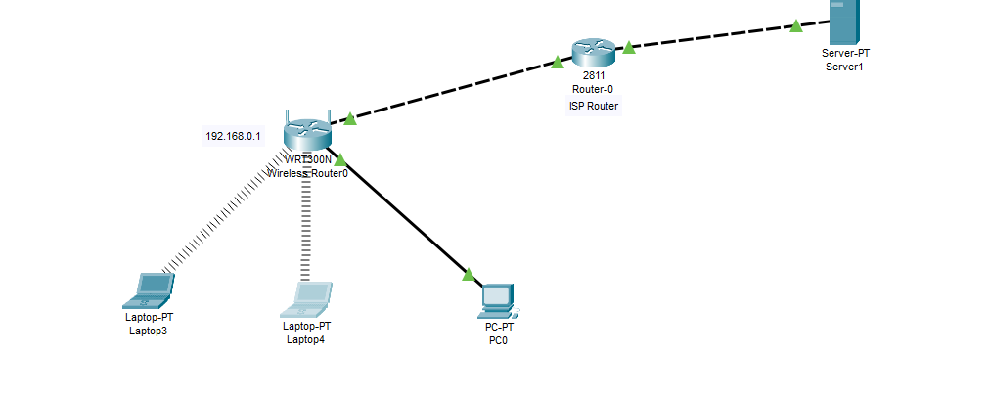

Internet Setup

